Title: **Nameplates and Three-Phase Motors** Test: 6

Course: Intro to Automation Unit: Manual Motor Control CLO: 1

Name ANSWER KEY Grade 20pts. Date ________________

**Objectives**

1. Student shall list items found on a single or three-phase motor nameplate.
2. Student shall calculate the acceptable input voltage range given the motors rated voltage.
3. Student shall identify how to reverse a single-phase and three-phase AC motors.

**Assessment**

Students shall demonstrate a comprehension of the objectives listed above by scoring a minimum of 75% on this Test. Grading shall be based on the answer key.

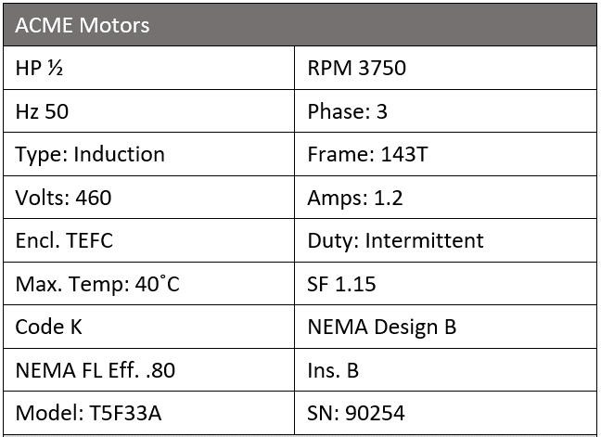**Instructions**

Answer each of the individual questions below.

1. What is the horsepower for this motor?   
   ½ HP
2. How many watts should this motor dissipate? 373W
3. What nominal voltage source would you use to connect to this motor? 480VAC
4. What is the acceptable range of voltage input to this motor? 414VAC to 506VAC
5. Which value on the nameplate indicates how the motor will cool itself?
   1. Duty
   2. SF
   3. Max. Temp.
   4. Encl.
6. The value on the nameplate indicating the appropriate ambient temperature for which this motor is rated?
7. Duty
8. SF
9. Max. Temp.
10. Encl.
11. This motor is suitable to be used in your home?
12. True
13. False
14. This motor can be loaded to more than its rated horsepower for short periods of time.
15. True
16. False
17. If this motor was installed in the U.S., it would spin faster than its rated RPM.
18. True
19. False

**Instructions**

Answer each of the multiple-choice questions below.

1. What determines the RPM value that is stamped on the nameplate?
2. The number of poles
3. Slip
4. Input frequency
5. All the above
6. Residential power is also termed three-phase power?
7. True
8. False
9. What is the most common type of motor found in industry?
10. DC Motor
11. Shunt-wound motor
12. Synchronous motor
13. Induction motor
14. This motor can change rotation at full speed.
15. True
16. False
17. This motor can run 24/7/365 except for leap-year.
18. True
19. False
20. All these nameplate values are based on the motor performing at;
21. Rated voltage
22. Max. Temp.
23. Full Load
24. Sea Level
25. All the above

**Instructions**

Design a stop/start motor control circuit using the a normally closed pushbutton, a normally open pushbutton and a three-phase motor starter. The circuit will also utilize a latching mushroom head pushbutton to act as an emergency stop. This circuit shall include overload protection for the motor. If the motor experiences an overload condition, power to the motor shall be disconnected and the control logic shall unseal the motor starter coil. The green light indicates the motor is running, the yellow light indicates an overload condition and the red light indicates that the motor has stopped. (4 pts)

Will the circuit to the right solve the instructions listed above? Why or why not. If needed, fix the drawing to meet the circuit instructions.